Title: Research Ethics Policy

POLICY HOLDER: Assistant Principal Higher Education and Adults
EXECUTIVE OWNER: Vice Principal Curriculum and Quality
VERSION NO: 2 (2022)

DUE DATE FOR REVIEW: October 2024

Accessibility: If you would like this information in an alternative format, e.g. Easy to Read, large print, Braille or audio tape, or if you would like the procedure explained to you in your language, please contact the College’s marketing team on 01603 773 169.
Further information: If you have any queries about this policy or procedure, please contact the name policy holder or the College’s marketing team on 01603 773 169.

Research Ethics Policy

Background
The College is committed to promoting high ethical standards in research and to safeguarding the dignity, rights and welfare of all those involved in research and the implementation of its results, as a fundamental part of its principles of research integrity.
The purpose of the Research Ethics Policy is to ensure that anyone engaged in research that involves City College Norwich is aware of the ethical principles that the College upholds, and has access to the guidance necessary to comply with those principles.

Review

Content
Part A. Introduction 2
Part B. Scope. 3
Part C. Principles. 3
Part D. Responsibilities and Procedures. 7

Part A. Introduction
A1 The purpose of this Research Ethics Policy is to ensure that anyone engaged in research that involves City College Norwich (CCN) is aware of the ethical principles that the College upholds, and has access to the guidance necessary to comply with those principles. The Research Excellence Framework (REF) 2021 defines research as ‘a process of investigation leading to new insights,
effectively shared.’ Additionally, there are forms of enquiry or investigation which may not strictly be defined as research, but which may carry risks to participants or infringe ethical principles or legal obligations, and need to be considered under the directions of this Policy.

A2 This Policy applies to all researchers:
- academic, research and relevant support staff employed by the College, and other individuals carrying out research at, or on behalf of, the College;
- all students undertaking research and their supervisors;
- any persons with honorary positions conducting research within, or on behalf of, the College;
- and the College also expects ethical oversight of research undertaken by any institution utilising CCN resources. This would/could include the College as a site for data collection.

A3 The Policy recognises that it is necessary to take account of specific legislative and funding body requirements.

A4 Although ethics should always be a consideration in research, this does not mean that full ethics review by the College is always required; ethics review supports good research practice and is not an end in itself.

A5 This Policy sets out conditions for establishing the ethics review requirements of research.

A6 The Policy also provides guidance on the review of projects which do not fit the definition of research but which may present ethical issues.

Part B. Scope
B1 The College’s Guidelines for Good Practice in Research outline what is expected of its researchers. This Policy and the associated guidance expand on this with respect to research ethics.

B2 The Policy:
- sets out the College’s core principles for undertaking ethical research;
- provides a framework for the conduct of ethical procedures within the College;
- outlines the relevant responsibilities and ethics review procedures within the College.

Part C. Principles
C1 When undertaking research, it is the researcher’s responsibility to consider and observe ethical principles and this Policy.

C2 In line with the Economic and Social Research Council (ESRC) Framework for Research Ethics, the College’s core principles for ethical research are:
- research should aim to maximise benefit for individuals and society and minimise risk and harm;
- the rights and dignity of individuals and groups should be respected;
- wherever possible, participation should be voluntary and appropriately informed;
- research should be conducted with integrity and transparency;
- lines of responsibility and accountability should be clearly defined; and
- independence of research should be maintained and where conflicts of interest cannot be avoided they should be made explicit.

C3 Ethics review is required for all research that:
- involves human participants. This includes research that:
  - directly involves people in the research activities, through their physical (or virtual) participation. This may be interventional (for example surgery, drug trials, interviews, questionnaires of a personal nature) or non-interventional research (for example surveys, observational research) and may require the active or passive involvement of a person;
  - indirectly involves people in the research activities, through their provision of, or access to, information, personal data and/or tissue;
  - involves people on behalf of others (for example legal guardians of children and the psychologically or physically impaired or supervisors of people under controlled environments, for example prisoners, school pupils).
- involves data not publicly available. For the purposes of this Policy, this would include confidential data and/or information to which you have access to, for example, as a result of employment.

  - involves animals. For the purposes of this Policy, animal research is defined as any research involving vertebrates and protected invertebrates such as cephalopods. It includes other invertebrates where these are registered as endangered or protected species, or involves large scale destructive sampling and/or the research is on specially protected sites. Research using post-mortem animal tissue such as that taken from abattoirs does not require ethics review.

- has a potential to affect the environment or cultural objects.

C4 Ethics review should be sought before the research has started, unless the requirement for review only becomes necessary during development of the project, for example, following a literature review or as the findings of the research start to be implemented in practice. Research must not start unless the ethics application has been reviewed and approved.

C5 Participants in research have, at the very least, all the rights as defined by law (for example, the Human Rights Act 1998, the General Data Protection Regulation (GDPR) and Data Protection Act (DPA) 2018, the Mental Capacity Act 2005, and relevant European Directives and conventions).

C6 In line with the ESRC’s Framework for Research Ethics, “Researchers should consider ethics issues throughout the lifecycle of a research project and promote a culture of ethical reflection, debate and mutual learning. The lifecycle of research includes the planning and research design stage, the period of funding for the project, and all activities that relate to the project up to – and including - the time when funding has ended. This includes knowledge exchange and impact activities, the dissemination process - including reporting and publication - and the archiving, future use, sharing and linking of data.”

C7 For research undertaken by staff or students of City College Norwich, these researchers will typically be joint Data Controller with City College Norwich. Collaboration with other institutions may result in joint Data Controllers.

C8 As students are using publicly funded facilities and work with academic staff, predominantly their supervisors, students will jointly own the intellectual property of work created as part of their studies with City College Norwich. Therefore, students must seek permissions from City College Norwich prior to publishing work created as part of their studies.

C9 Before leaving the College at the end of a contract or completion of studies, researchers must first discuss management and retention of all research data for which they are responsible with their line manager, project supervisor, or Head of Department as appropriate, to ensure a copy pf the data is retained by the College, and whether the researcher will take a copy. These decisions must conform with requirements and restrictions arising from applicable legislation, funding, contracts, ethical approval, and policies.

C10 Researchers should take into account legislation and cultural standards relating to the country in
which the research is carried out. For research activities overseas, researchers must be able to
demonstrate with documentary evidence that they are in compliance with relevant legal and ethical
requirements of the host overseas country. Researchers and all partner organisations will make sure
that appropriate measures are in place to protect all involved in the research and must ensure that
procedures are in place to handle any breach of Sections 2 and 6 of the Department for International
Development (DFID) Supply Partner Code of Conduct, and make clear the legal ramifications of such
a breach
C11 The nature and ethical standing of all stakeholders involved in a research project should be considered in the context of their fit with the College’s mission and values.

C12 Where organisations involved in research prescribe specific policies in this context which are not necessarily legal requirements, these should be observed, in so far as this does not conflict with ethical standards.

C13 As a condition of their employment, all staff are required to adhere to the policies, rules and procedures of the College. Researchers are individually responsible for adhering to the College’s Research Ethics Policy under the leadership of the Principal, who are ultimately responsible for all activities performed in the College.

C14 Students are governed by the College’s Regulations.

C15 Failure by a member of staff or a student to comply with the College’s Research Ethics Policy will be investigated under the ‘Student Disciplinary Procedure’, and be subject to disciplinary action as appropriate.

C16 Certain types of research must gain approval from a NHS Research Ethics Committee before starting. This includes research involving:
- NHS patients;
- the storage of human tissue regulated under the Human Tissue Act 2004;
- human participants lacking capacity to provide informed consent to participation;
- health-related-research involving prisoners;
- clinical investigations of medical devices;
- clinical trials of investigational medical products.
C17 The Policy will be implemented by procedures determined by the Terms of Reference for CCN- REC. The committee is established to:
- Monitor and review the operation and effectiveness of the College’s ethical procedures and committee membership;
- Make recommendations for amendments where and when necessary to ethical procedures and practices to ensure best practice;
- Conduct ethical scrutiny of proposals

C18 CCN Ethics Process:

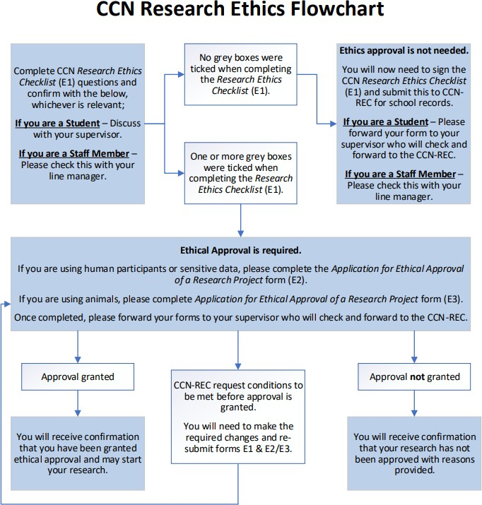

Part D. Responsibilities and Procedures

D1 This Policy cannot address all possible ethics issues. Researchers are expected to maintain awareness of ethical issues as they arise and seek guidance from their supervisor and/or CCN-REC Chair in the first instance.

D2 The primary responsibility for considering ethics in research lies with the lead researcher and student supervisor.

D3 Researchers are expected to consider the ethical implications of their research and, depending on its nature, the socio-cultural consequences of it for the participants involved. This should be considered in the context of a range of other potential stakeholders, including fellow researchers, their School and the College and the academic profession.

D4 Research activities put forward for formal ethics review:
- require ethics approval prior to commencement of the research activities;
- cannot continue if ethics approval has been withdrawn or suspended;
- may have to request review during the course of the research if the research plan alters.
- must comply with the conditions set by the College or other recognised bodies.

D5 Any request for retrospective ethics review of a project which has already started, will only be considered in exceptional circumstances. Retrospective approval is only likely to be given if there have been procedural failings. If retrospective approval is not given, the decision whether to proceed to academic misconduct procedures will be dealt with on a case by case basis and will depend on the level of risk that was posed to the participants/researchers.
D6 Surveys and market research carried out within CCN will require ethics review.
D7 Anyone planning a project should use the Research Ethics Checklist (E1) to identify potential issues and assist with preparing any subsequent application for ethical review.
D8 The decision of the Ethics Panel should be considered as final and there is no recourse to appeal.
D9 Ethics review does not, in and of itself, ensure compliance with the data protection legislation. Where staff or students are processing personal data for which the College is the Data Controller, they must familiarise themselves with the requirements for compliance with both the GDPR and the DPA2018. This includes obligations to provide certain information to participants, and the legal requirement to undertake a Data Protection Impact Assessment (DPIA) for any processing likely to result in a high risk to individuals. The College’s Information Compliance and Policies Office can provide guidance and must be consulted on any DPIA undertaken.

